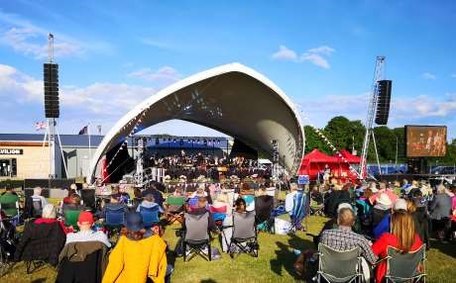

The Newsletter for Middleton on the Wolds

Issue No 40

AUGUST 2022

NEXT COPY DATE

14th AUGUST

Do you have anything that you want to sell? Maybe now is the time to take advantage of our special offer advertising prices (see opposite page). Don’t forget that The Messenger is delivered to every household in Middleton.

Please send in your contributions by the end of the copy date. If I don’t acknowledge them please get in touch to make sure they have arrived.
Thank you
Lyn
4 The Paddocks 219500 middletonflyer@yahoo.com

If you have any ideas, comments or complaints (especially complaints) you want to share then send an email to middletonflyer@yahoo.com.
Remember, we can’t respond unless we receive your message
The cover photo is one I took of the recent Driffield Midsummer Spectacular Charity Concert (taken before the rain!).
Lyn

Advertising Special Offer 10% off

Help support the Middleton Messenger.
We have a special feature regarding advertising rates, with the introduction of ¼ of a page next month for that issue. This is in order to gauge its popularity in the future. If it goes well, it will become a continuing feature in our Messenger.
Any queries or potential adverts please contact Tina at middletonflyer@yahoo.com or 01377 217242.

Rates Month Year
Whole Page £25.00 £22.50 £150 £135
½ Page £15.00 £13.50 £100 £90
⅓ Page £10.00 £9.00 £60 £54
¼ Page £5.00 - special price

QUIZ PAGE
- What is the name of the Market Weighton Tall person?
- Where was St.John of Beverley born?
- What is name the oldest horse race in England?
- Where will you find the Black Mill?
- What is the name of the well in Market Weighton?
- What was the name of Middleton's former pub?
- Who lives at Dalton Hall?
- Where is Yorkshire's largest fresh water lake?
How many lighthouses are there between the River Humber and Scarborough
9
(excluding Scarborough)?
10 Where is the capital of the Wolds?
Quiz set by Rowland Wooldridge
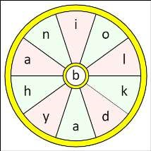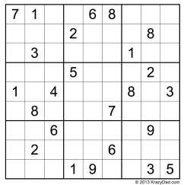
All answers on
page 14

SEASONAL WORD WHEEL

Try to find the timely word or words
and then create as many words possible
with the letters in the word wheel. You
can only use each letter once and every
word must include the letter in the
centre of the wheel.

SUDOKU

St Andrew’S church
Services for August
Sunday 7th | 10.30am | Morning Prayers. RL
Sunday 14th | 10.30am | Holy Communion. Rev’d Jane Anderson
Sunday 21st | 10.30am | Holy communion.
 |  | Rev’d Canon Kate Goulder
Sunday 28th | 10.30am | Holy Communion. Rev’d Anne White

Note: The Benefice service on 31st July is at Kilnwick at 10.00am. Ministry Team

The wolds METHODIST CHURCH bainton
Services for August
Sunday 7th 10.30am | Service at the Wolds Methodist Church.
 | Miss Margaret Collinson
Sunday 14th 10.30am | Service at the Wolds Methodist Church.
 | Pastor John Gleaves
Sunday 21st 9.00am | Café style worship with breakfast at the Wolds
 | Methodist Church. Rev Dr Richard Teal.
 | Holy Communion.
Sunday 28th 10.30am | Service at the Wolds Methodist Church.
 | Rev Keith Himsworth

There is no Coffee Morning at the Wolds Methodist Church in August

a note from your vicar
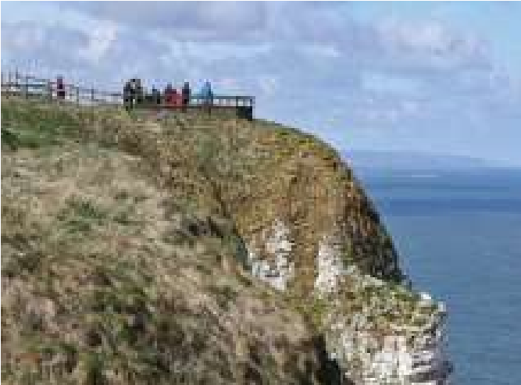
A couple of weeks ago we made our first visit to Bempton. At this time of year around ½ a million sea birds cling to the sides of the cliffs and rear their young, demanding offspring. How they don’t fall off I do not know. It was a very educational visit, I now know what a Guillemot looks like (creamy coloured head) and that all this time when I have been calling the large squawky sea birds who pinch your chips ‘sea gulls’ I was
wrong, and they might be herring gulls, kittiwakes, Fulmars or many other kinds of gull.
But what I had most hoped to see were the Puffins. We had a lovely walk along the well-maintained paths to the look-out points – I could not believe the noise! The weather was very changeable - sunshine, cloud, dark cloud and heavy rain, thunder and even lightning.
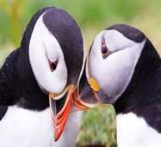
I did see one puffin – it must have been young as it did not have its multi coloured beak but a bright red/orange one (a baby puffin is called a ‘Puffling’). When we returned to the RSPB café and shop, I saw a fridge magnet which said ‘I saw a puffin at Bempton Cliffs’ - not ‘Puffins’ plural, which made me think these little birds are quite elusive and also very smart as they do not cling onto the cliff face but live in burrows where they are protected from the elements and predators and very hard to spot! What did strike me, though was how so many different breeds of bird live quite happily side by side not in separate colonies.
The school holidays have now begun and August can feel like a less frantic time for many – long, warm days (hopefully) with time to just sit and be. Many churches suspend all committee meetings for a whole month so people have time to rest and recharge.
Whether you are visiting the sea side, travelling or sitting in your garden I hope that during this next month you will have time to do those things which give you joy.
Take care Jane

Local Birds & wildlife
Red Kite

First of all, thanks to Janny and Barry for their patience – here are the pictures that I didn’t manage to include last month: “Here are two photos of the woodpecker that has been coming into the garden many times a day – hoping
they will bring the babies back to the feeders like they have before. We have also had lots of baby birds coming in the garden. The meadow pipit was
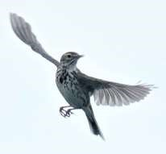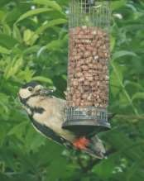
taken at Bempton Cliffs.
”

At the end of June Hazel reported seeing five stoats bouncing across Warter Road outside the village, and Sheelah saw a group of red kites circling above a rye field that was being cut for silage and diving down into it – were they spotting small mammals fleeing the machinery?
Although I haven’t been out and about, in the last couple of days the wildlife has very considerately come to me; I was woken up in the early hours one night by a loud hissing sound like a very large snake that had somehow got hold of a child’s small plastic trumpet and was giving a concert while sitting on the roof directly above my open window. While I didn’t actually see this enthusiastic performer, what I did see, beautifully silhouetted against the sky, was a parent owl coming in to feed it's youngster. It made several visits, at one point flying to a nearby leylandii, having a rummage and then coming back again. A real treat, and well worth waking up for!
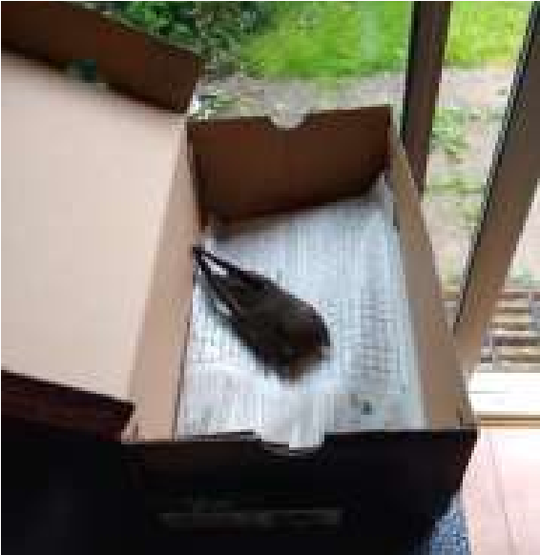
The next visitor was actually brought to me by Val from over the road; a young swift that had been found apparently exhausted on the ground. I was able to get it to take some water from an eye-dropper, which slowly revived it. It was flapping it’s wings very strongly later in the afternoon, and took off but disappeared into a nearby bush. I will come back to this shortly ….
Later that evening I was pulling the curtains when I saw an enormous hedgehog on the lawn. I haven’t seen one in the garden for a
very long time, so this was a wonderful sight. However, and this is where two happy stories collide with a sad outcome for one, the next morning there was half of a swift on the lawn, but presumably a very happy hedgehog somewhere in the undergrowth.
Finally, I got very carried away with the cockchafer last month, and now Hazel has told me that in fact they are not actually very good for gardens, as the larval grubs lurk under the lawn eating the roots of the grass and causing brown patches. However, looking on the bright side, all our lawns are getting brown patches now anyway because of the hot sun and lack of rain, so perhaps the odd cockchafer can get away with it!
Please let me have any photos, anecdotes and interesting sightings for next month, and I will try and keep more up-to-date.
Barbara
Barbara, Paul and Rob Lavender would like to thank everyone for their support and kindness following the sad and unexpected loss of Ian last month. Your cards and good wishes were really appreciated, and made a big difference.

Middleton book group
July Books

Shuggie Bain is the debut novel by Scottish/American author Douglas Stuart, published in 2020 and awarded the Booker Prize in the same year. Not an easy read, it tells the story of young Hugh, known as Shuggie, growing up with an alcoholic mother in 1980s post-industrial working class Glasgow.
A description of the book in the Telegraph encapsulates the issues in the book as joy, sorrow, anger, disenchantment, passion, desire, envy, hate, disappointment and a strange, luminous love. It received a mixed reception from members of the group.

Women of the Dunes by Sarah Maine proved a popular choice for most members. Set in the sea-lashed coast of West Scotland, the story entwines the lives of three very different women: a ninth century Norsewoman, a nineteenth century woman and a twenty first century archaeologist! Libby. The story connects the three timelines through many fascinating myths and legends.
Jean

Meetings are on the second Tuesday in the month. Hopefully we will be able to meet in a member’s graden now that we are into the summer months. Please get in touch to check - Lyn, 219500 or lyndennis456@gmail.com

The next books for discussion are:

Men Don’t Cry by Faiza Guene
The Vanishing Act of Esmo Lennox by Maggie O’Farrel

parish council news

JUBILEE CELEBRATION MUGS

As part of the Jubilee celebrations the Parish Council purchased a quantity of mugs with the intention of offering everyone in the village who are in receipt of a state pension a complimentary gift. These were available and some were distributed at the Gala but we still have a number of mugs available for those eligible.
In order to further help with their distribution they will be available free for collection from the READING ROOMS on Wednesday 10th AUGUST between 9am and 12 noon.
For those who are unable to collect or arrange for them to be collected on their behalf a home delivery service will be available on the afternoon of that day between 2-4pm. If you wish to take up this offer please e mail Nick
Jones on nj@motwparishcouncil.com stating your NAME/S and ADDRESS for delivery. If you’re not in the mug will be left by your front door. Claim one now and enjoy your morning tea just like the Queen does!
Thank you
Nick Jones
Parish Councillor

LOCAL HISTORY
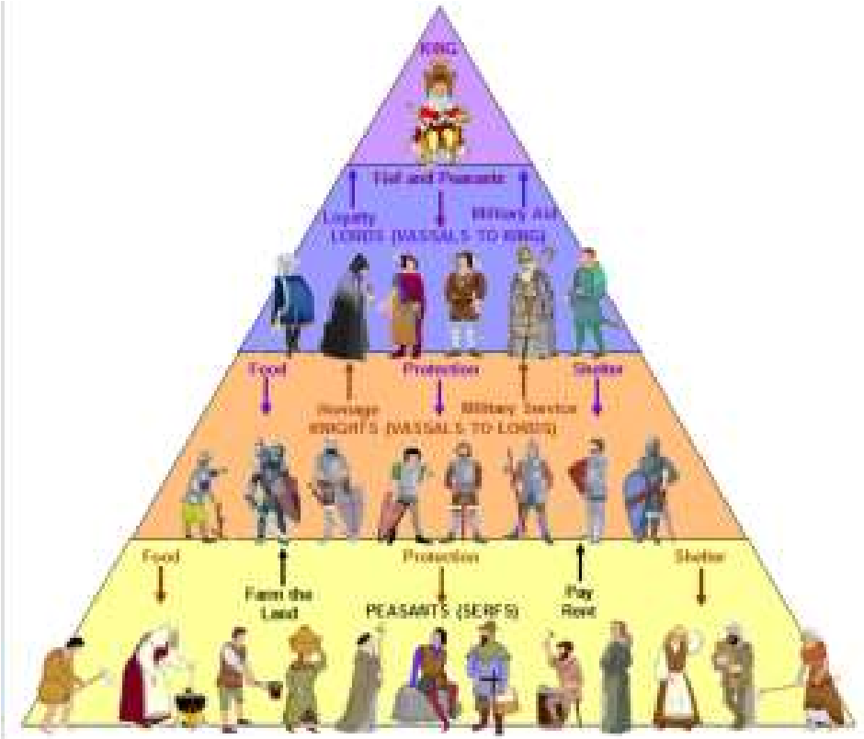

MIDDLE AGES

The Feudal System

The decline of feudalism had started when the greater barons and lesser knights began to divide; the former concentrating on warlike activities and the latter forming the beginnings of the squirearchy which would dominate the rural scene for centuries and which increasingly used wage rather than serf labour. This class concentrated on agricultural production, particularly wool and collaborated with the new merchant class in the emerging towns in the trading of this commodity. It was in these post conquest centuries that new ideas on the administration of justice were established and the first parliament summoned.

In the context of civil disputes it is of interest to note that at Middleton
–on--the-Wolds in 1409 a country jury reported to the Sheriff of Yorkshire that there were floods in the meadow and pasture of Gerard de Usflet, and of Anlaby, Swanland, Hessle and Ferriby, because Hull did not keep its watercourse clear from Spryngheved through Darlynghamdyke to the town gates. This led to a lawsuit in Westminster Hall in the Michaelmas term of 1413.

The upside of Norman rule had been that the people knew who was in charge and were spared the uncertainty experienced in other countries where local warlords vied for power; a state of affairs which England eventually experienced during King Stephen’s reign and the dynastic struggles in the so called Wars of the Roses.

In this period of our history the rural peasant would have had limited knowledge of the countryside away from the home village; he or she would have regarded the inhabitants of other settlements as foreigners; however the kind of agriculture practised at the time would have necessitated cooperation among the workers in the village. Loyalty to the village was the basis of law and order and strangers were looked on with suspicion. The landowning class however would no doubt have known more about the outside world particularly when war was involved such as the conflict with France known as the Hundred Years War. At the end of this struggle in 1455 there was the start of a sequence of plots, rebellions and battles for dynastic reasons named in later centuries the Wars of the Roses involving the Lancastrians, Red Rose and Yorkists White Rose. The military capabilities of each side were strengthened by the influx of returning nobles from the previous war with their bands of physically strong soldiers, the latter often being unfit for peaceful employment and consequently eager for violent activities.
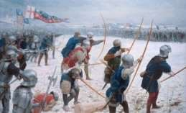
The story of the war was complicated but as the names of the antagonists suggests there was action in Yorkshire including the bloodiest battle ever fought on English soil at Towton near Tadcaster during a snowstorm on the 29th March 1461 (Palm Sunday) involving an estimated fifty

thousand participants. The result was the displacement of the Lancastrian king Henry the sixth with the Yorkist Edward the fourth.

Among the would be participants of the battle was the 13th. Baron
Clifford whom Shakespeare in his play Henry VI part 3 refers to as “Butcher Clifford cruel child killer and treacherous coward.” It is said that he ruthlessly stabbed the youthful Rutland after the battle of Wakefield in 1460 and set the Duke of York’s head on a pole decorated with a paper crown and took it to Queen Margaret. However he was killed on the eve of Towton fighting on the Lancastrian side. His son Henry lived in disguise as a shepherd on the hills around Londesborough after the battle which earned him the name “Shepherd Lord.”

The fortunes of the family recovered after the battle of Bosworth Field in 1485 when the estates were restored including land in Middleton. Henry’s descendents became Earls of Cumberland and one heiress married Richard Boyle the first Earl of Burlington.The family was to aquire land in Kiplingcotes and Middleton in 1601.

Edward the fourth was succeeded to the throne for a mere seventy eight days by his son Edward who with his brother Richard was the subject of one of the most famous unsolved disappearances in English history known as the Princes in the Tower. He was followed by Edward the fourth’s younger brother the much maligned Richard the third; considered by some to be a friend of the north; but still considered as the prime suspect in the disappearance of the princes. He was killed at the battle of Bosworth Field in 1485 an event which signalled the arrival of a new dynasty: the Tudors who were destined to take the country in different directions.

Geoff Wisher

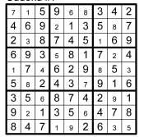
BANK HOLIDAY

QUIZ
1

Giant Bradley

2

Harpham

3

Kiplincoates Derby

4

Beverley Westwood

5

St. Helen's Well

6

The Rose and Crown

7

Lord Hotham

8

Hornsea (the Mere)

9

4
-
Spurn Point, Paul, Withernsea,
Flamborough, 5
-

if you include the
redundant one at Flamborough

10

Driffield

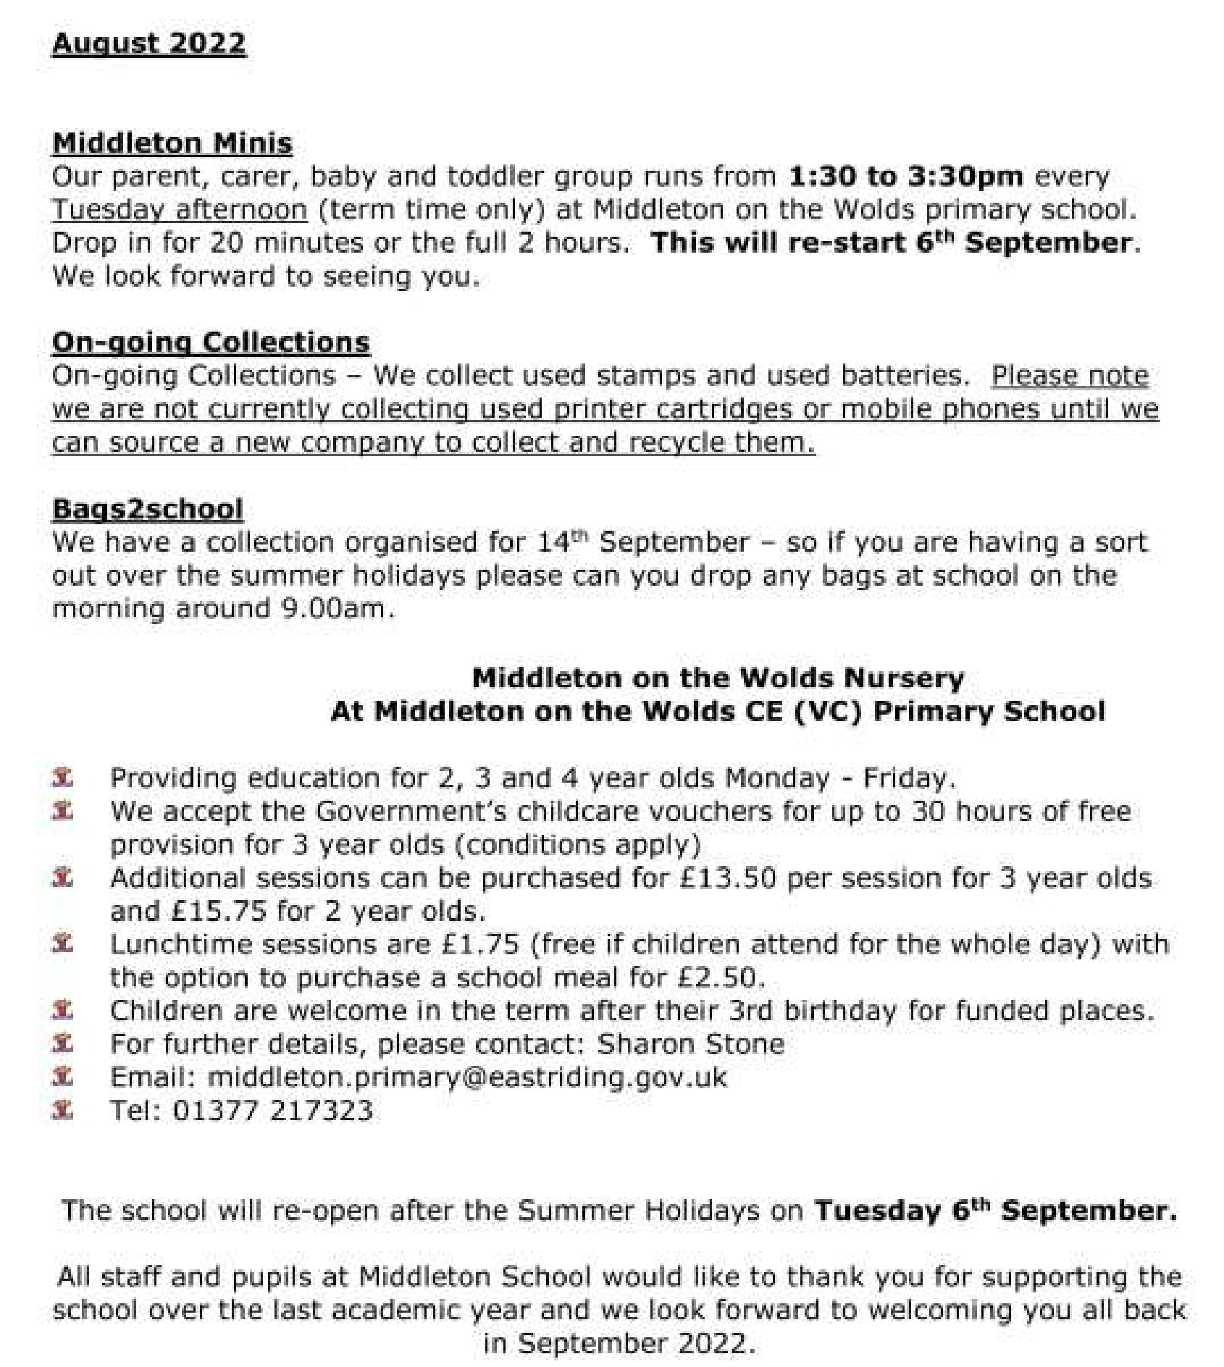
Middleton on the wolds ce ve school
Executive Headteacher: Mrs E Harros

Station Road, Middleton on the Wolds, Driffield YO25 9UQ

E
-
mail:middleton.primary@eastriding.gov.uk Tel: 01377 217323

Advertising Feature

Advertisements
Advertisement

Advertising Feature

Regular group activities
Weekly Groups
Monday Pilates |  | 5.00-6.00pm Village Hall
Tuesday Tai Chi |  | 2.30-4.00pm Village Hall
Wednesday Line Dancing |  | 7.30-9.00pm Village Hall
Thursday Middleton Movers  August |  | 2.00-3.30pm Village Hall
3 Village Hall Committee |  | 2.00pm Village Hall
9 Book Group |  | 10.30am Driffield
14 Womblers Litter Picking |  | 10.00am Lime View
 | LOCAL CONTACTS Bell Ringing Chris Atkin |  |  | 217285
 | Book Group/Middleton Movers |  | Lyn Dennis | 219500
 | Bowls Club |  | Rob Bradley | 217435
 | Country Women’s Association |  | Christine Johnson | 217374
 | First Responders |  | Chris Brent | 219469
 | Line Dancing |  | Pat Pottage | 217516
 | Methodist Chapel |  | Jane Gray | 07870 562455
 | Middleton Messenger |  | Mike Kelly | 07713 620912
 |  |  | Lyn Dennis | 219500
 |  |  | Tina Walker | 217242
 | Middleton Green Group |  | Liz Naylor | 219072
 | Middleton Womblers |  | Andrew Naylor | 219072
 | Parish Clerk |  | Sandra Morrison | 01262 470496
 | Pilates |  | Ian Stephenson | 07973 755717
 | Reading Rooms |  | Kath Bentley | 217456
 | Recreation Club |  | Dave Newlove | 07901 833784
 | St Andrew’s Church |  | Rev Jane Anderson | 219471
 | St Andrew’s Church Wardens |  | Chris Brent | 07766 162743
 |  |  | Lesley Kelly | O7907 451046
 | Table Tennis |  | Louise Newlove | 217801
 | Village Hall |  | Lyn Dennis | 219500
 | Village History Geoff Wisher |  |  | 217517
email: middletonflyer@yahoo.com page 20

